- Ilustrasi Gambar: Abstrak Grafis (Graphical Abstract)/Ringkasan Visual (Graphical Summary)
Ketentuan Pembuatan Abstrak Grafis (Graphical Abstract)/Ringkasan Visual (Graphical Summary):
- Abstrak grafis/ringkasan visual terdiri atas sebuah gambar yang secara visual merangkum temuan utama dari tugas akhir.
- Abstrak grafis/ringkasan visual disusun secara singkat dan berdiri sendiri, menyampaikan tujuan dan hasil penelitian, serta disajikan dengan cara yang menarik secara visual dengan resolusi gambar minimal 300 dpi.
- Utamakan penggunaan ilustrasi gambar hasil tugas akhir, meliputi foto hasil penelitian, grafik, diagram, histogram, sketsa, dan sebagainya.
- Jika mengambil elemen atau foto di luar hasil tugas akhir, perhatikan penggunaan elemen berhak cipta, serta pastikan hanya menggunakan elemen yang bersifat bebas pakai, memiliki izin, atau mencantumkan atribusi yang sesuai apabila diperlukan.
- Mahasiswa wajib mendeklarasikan penggunaan AI di halaman pernyataan mengenai tugas akhir, sumber informasi, penggunaan AI, dan pelimpahan hak cipta, jika digunakan dalam pembuatan abstrak grafis/ringkasan visual.
- Abstrak grafis (graphical abstract)/ringkasan visual (graphical summary) ditulis dalam satu halaman.
- Judul diletakkan di bawah abstrak grafis/ringkasan visual, maksimal 6 kata tidak termasuk kata depan dan kata hubung.

- Bidang Sains, Teknik, dan Kesehatan

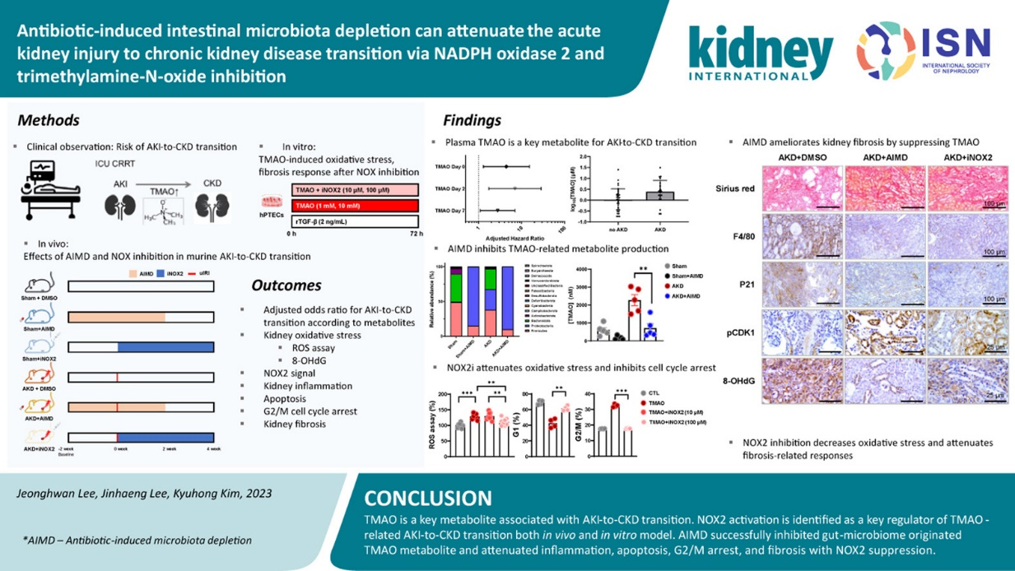

Graphical Abstract Title Maximum Six Words,
Excluding Prepositions and Conjunctions

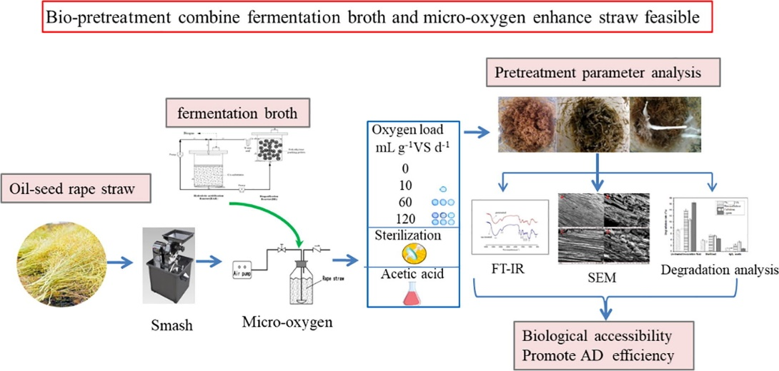

Graphical Abstract Title Maximum Six Words,
Excluding Prepositions and Conjunctions

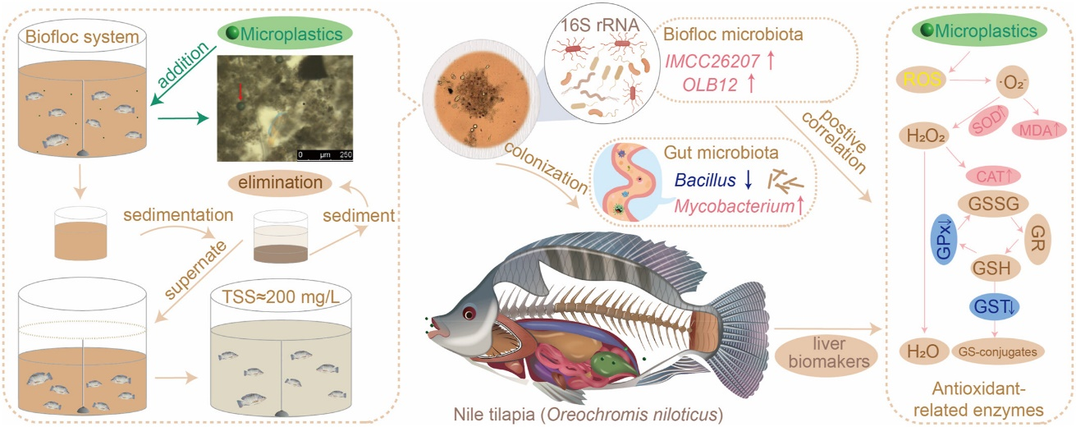

Graphical Abstract Title Maximum Six Words,
Excluding Prepositions and Conjunctions

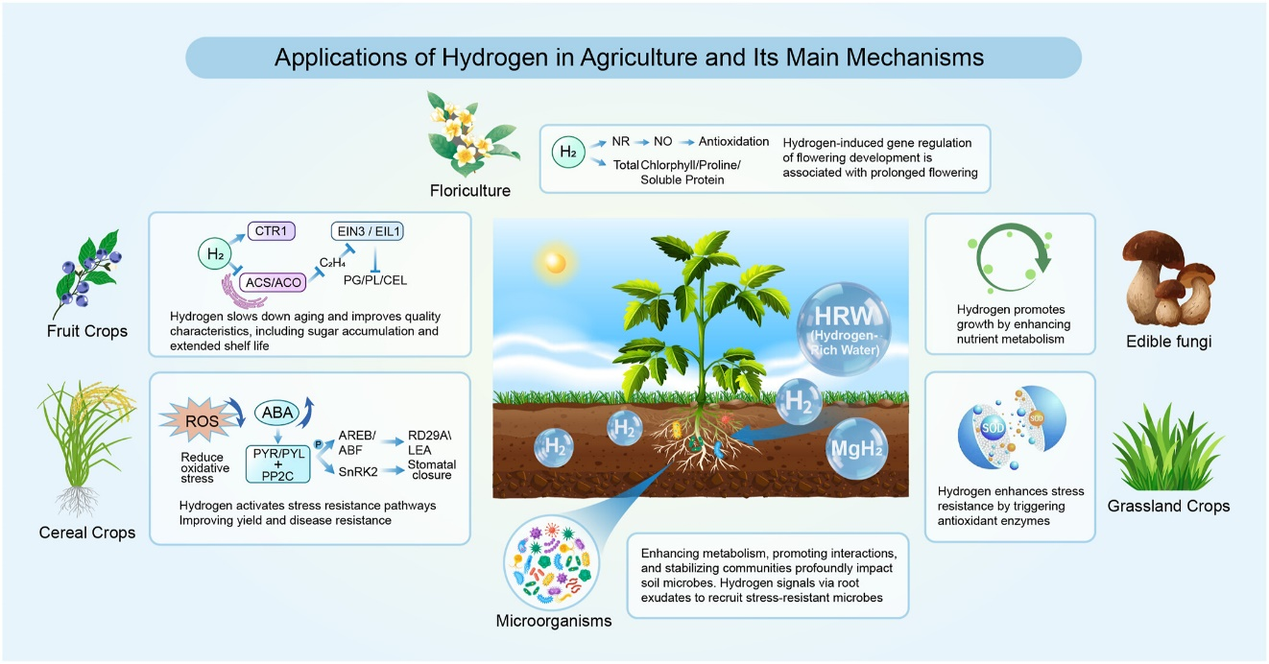

Graphical Abstract Title Maximum Six Words,
Excluding Prepositions and Conjunctions

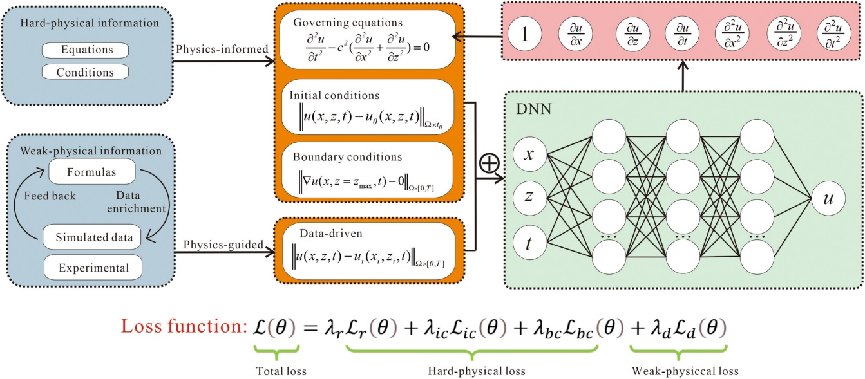

Graphical Abstract Title Maximum Six Words,
Excluding Prepositions and Conjunctions

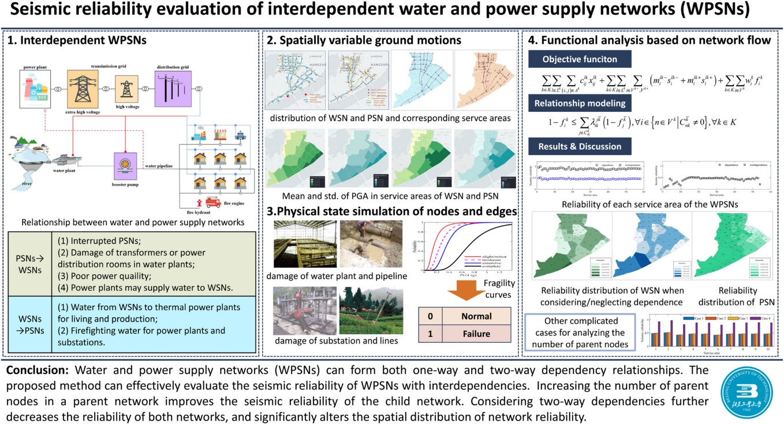

Graphical Abstract Title Maximum Six Words,
Excluding Prepositions and Conjunctions

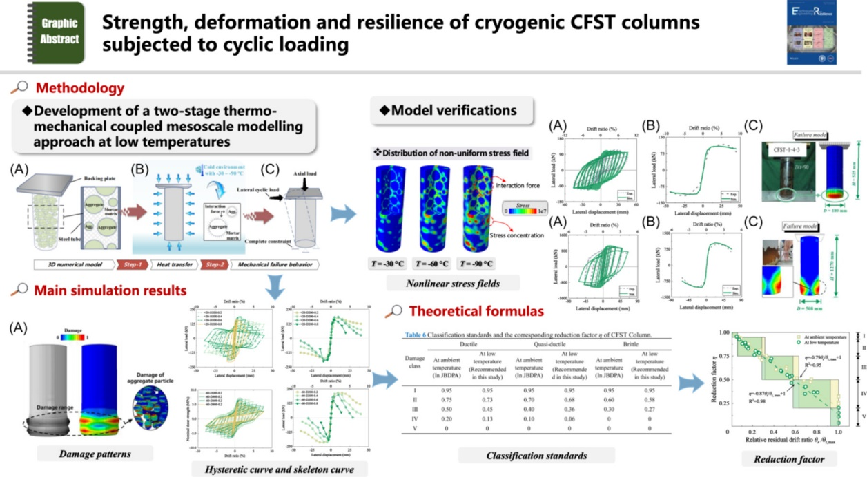

Graphical Abstract Title Maximum Six Words,
Excluding Prepositions and Conjunctions

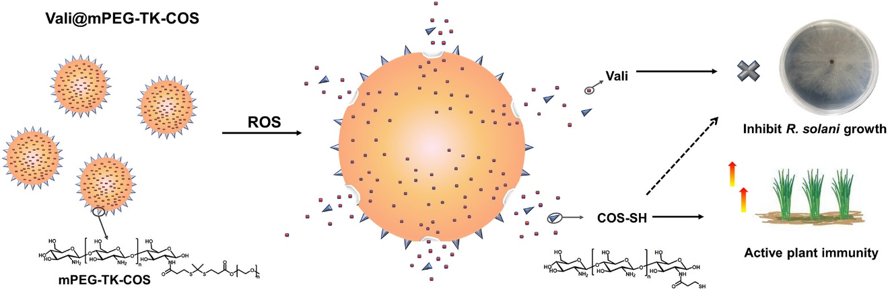

Graphical Abstract Title Maximum Six Words,
Excluding Prepositions and Conjunctions

  - Bidang Sosial, Ekonomi, dan Humaniora

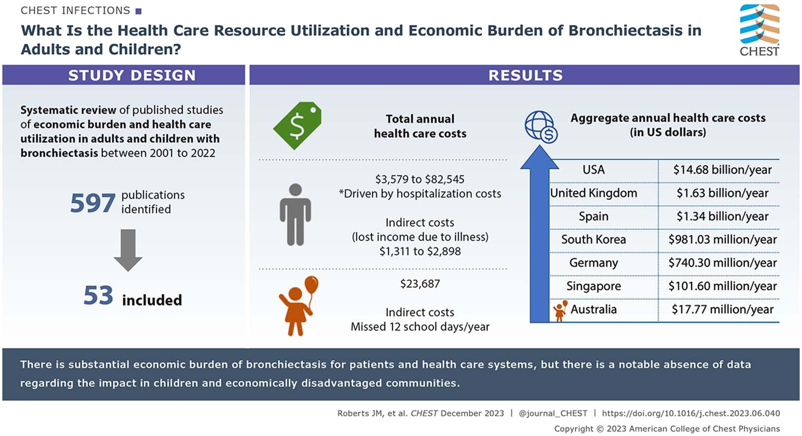

Graphical Abstract Title Maximum Six Words,
Excluding Prepositions and Conjunctions

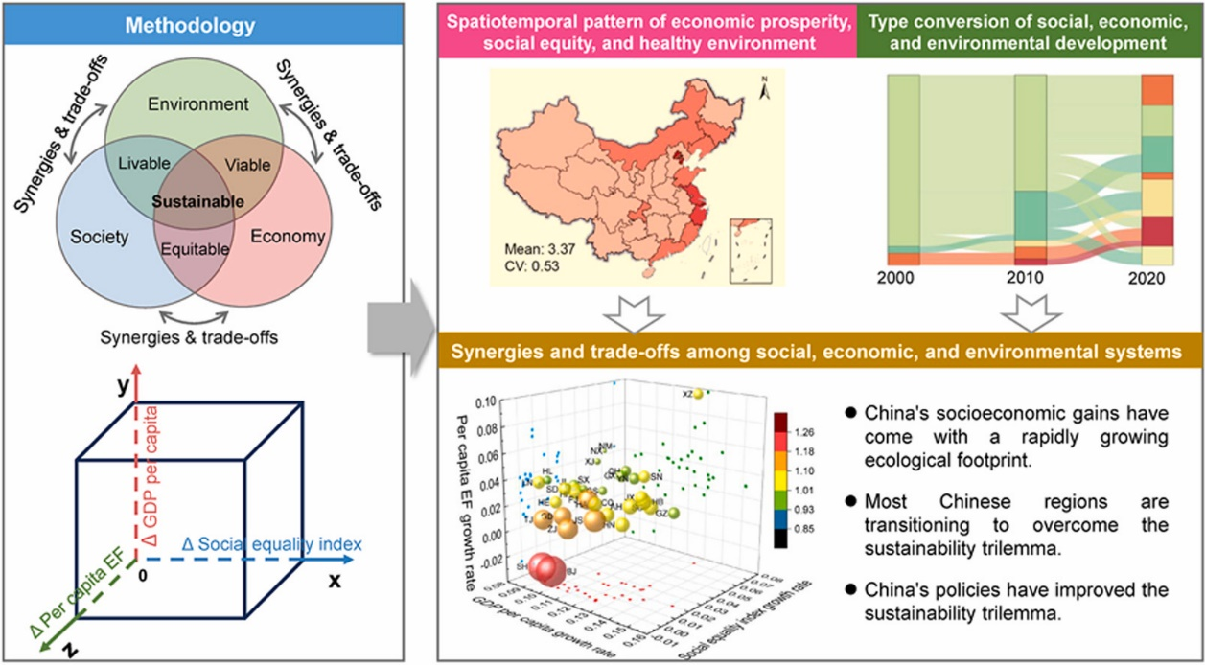

Graphical Abstract Title Maximum Six Words,
Excluding Prepositions and Conjunctions

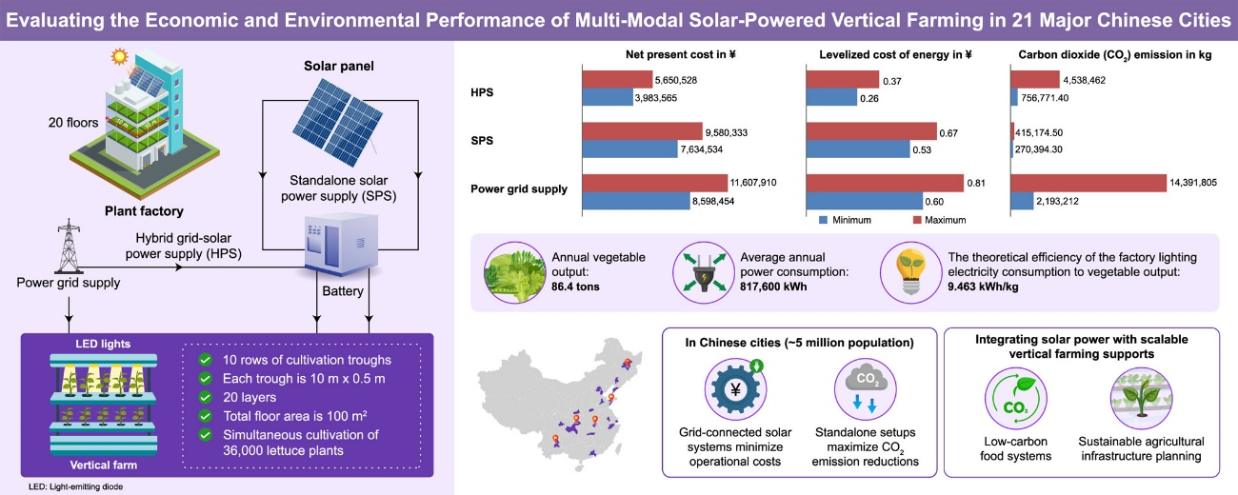

Graphical Abstract Title Maximum Six Words,
Excluding Prepositions and Conjunctions

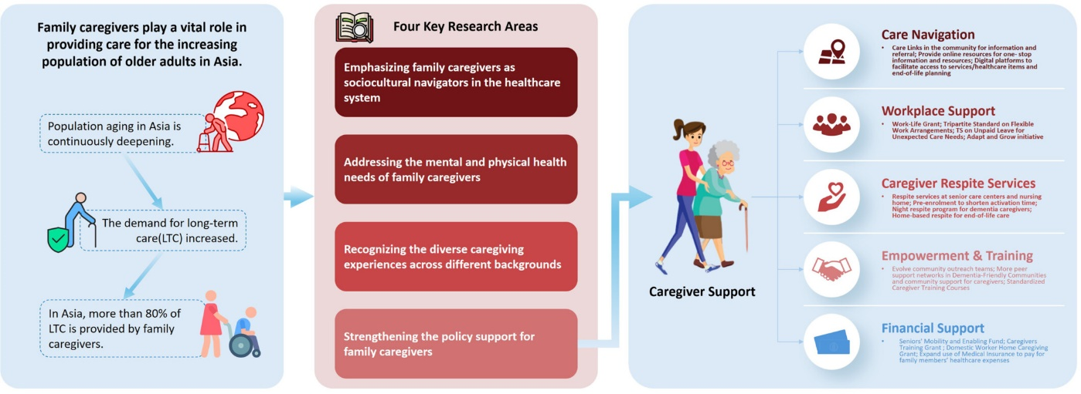

Graphical Abstract Title Maximum Six Words,
Excluding Prepositions and Conjunctions

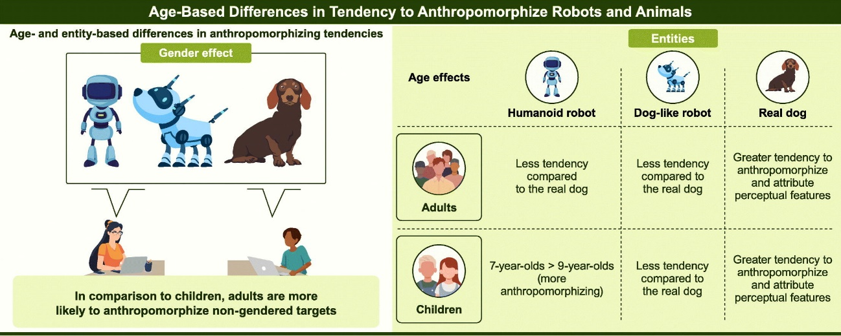

Graphical Abstract Title Maximum Six Words,
Excluding Prepositions and Conjunctions

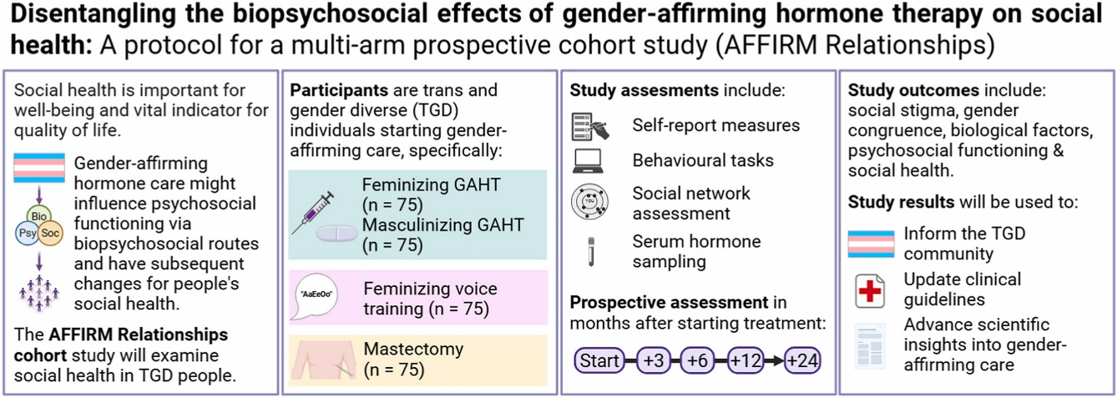

Graphical Abstract Title Maximum Six Words,
Excluding Prepositions and Conjunctions

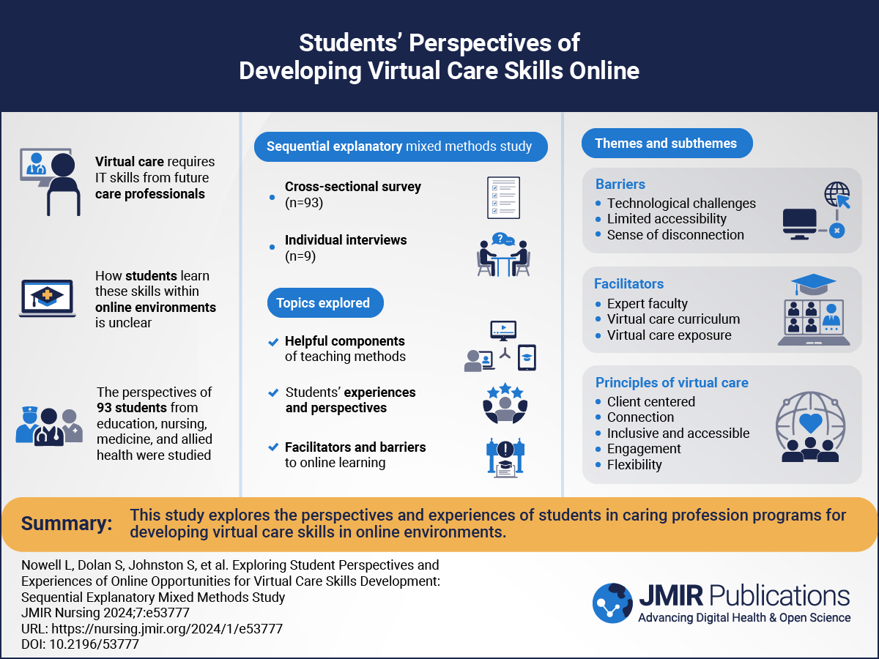

Graphical Abstract Title Maximum Six Words,
Excluding Prepositions and Conjunctions

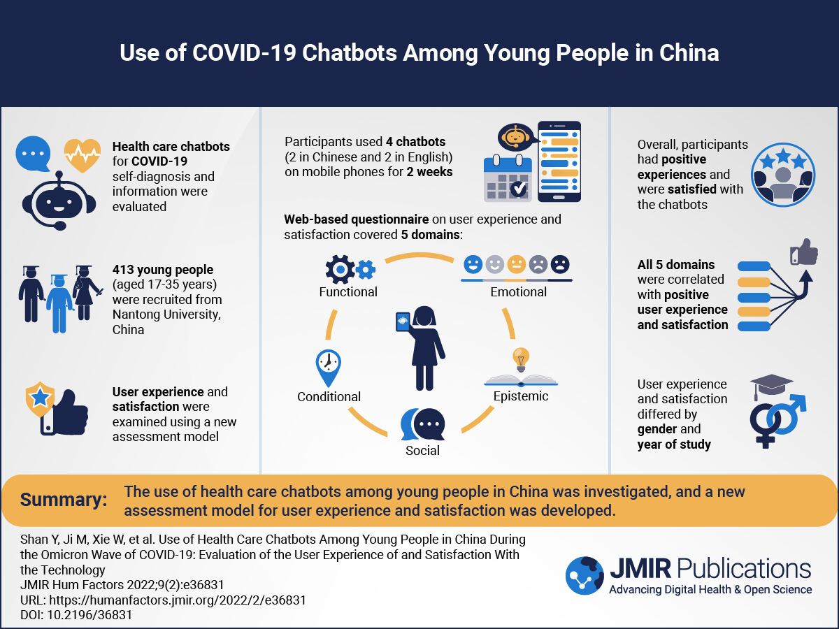

Graphical Abstract Title Maximum Six Words,
Excluding Prepositions and Conjunctions

  - Prototipe

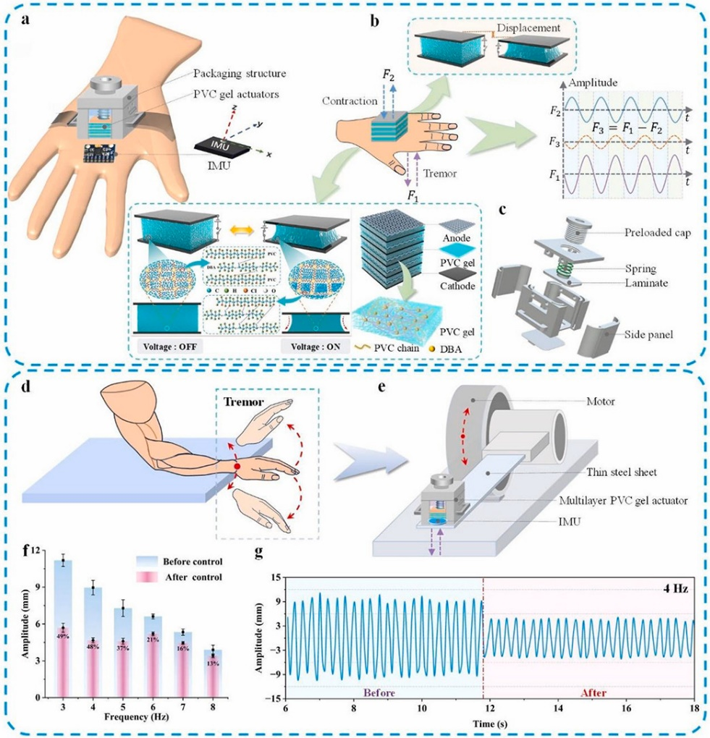

Graphical Abstract Title Maximum Six Words,
Excluding Prepositions and Conjunctions

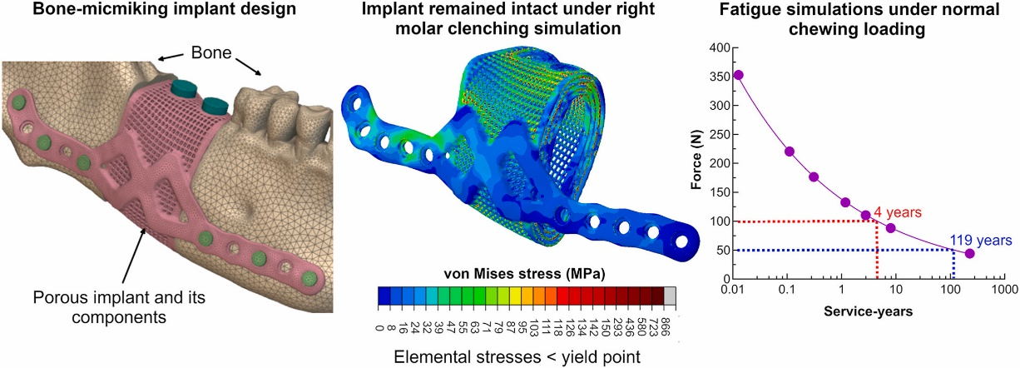

Graphical Abstract Title Maximum Six Words,
Excluding Prepositions and Conjunctions

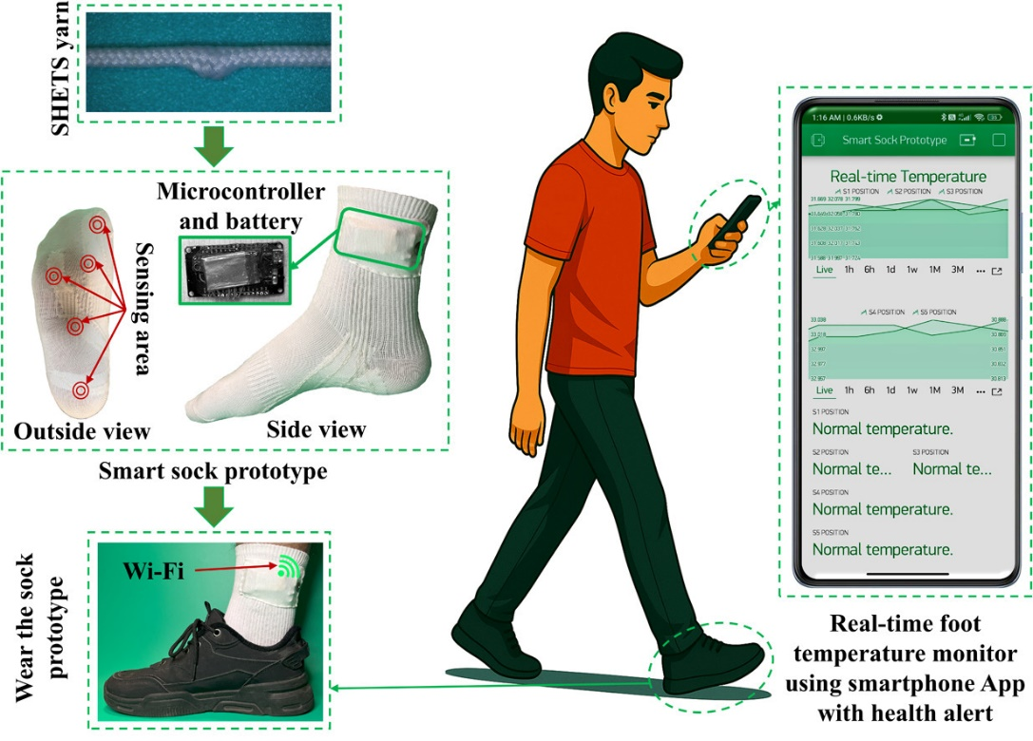

Graphical Abstract Title Maximum Six Words,
Excluding Prepositions and Conjunctions

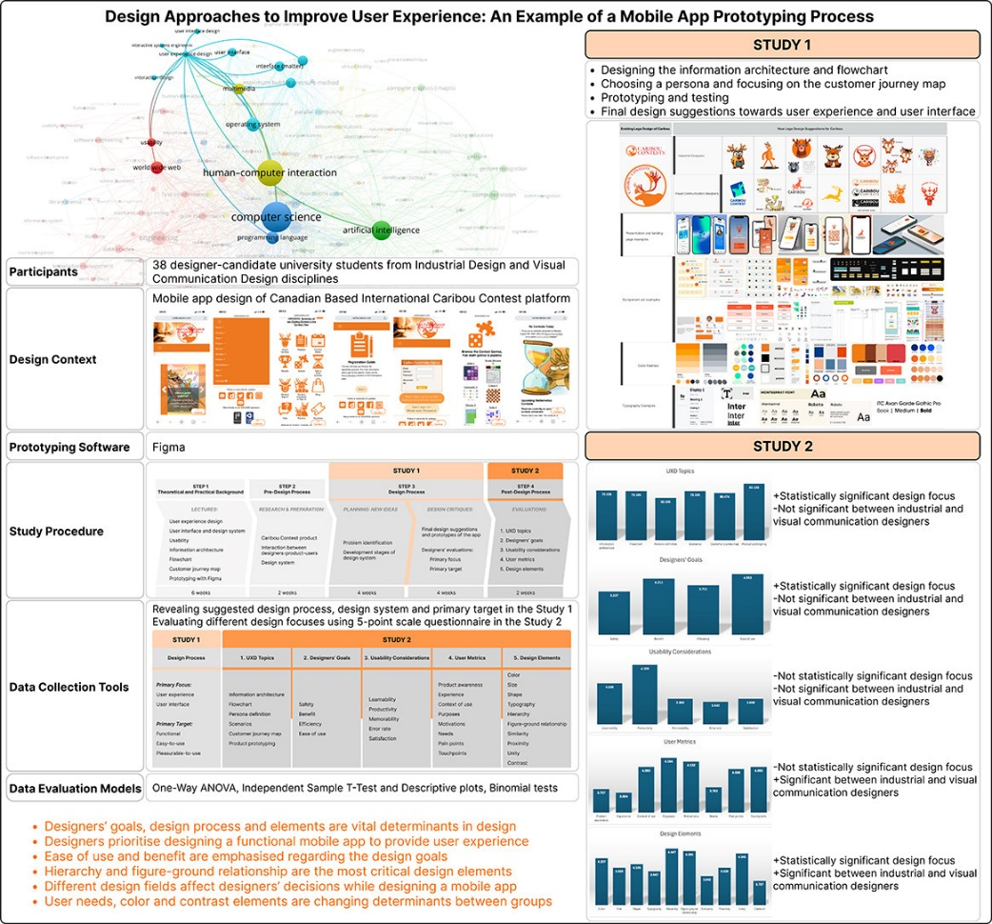

Graphical Abstract Title Maximum Six Words,
Excluding Prepositions and Conjunction

  - Proyek

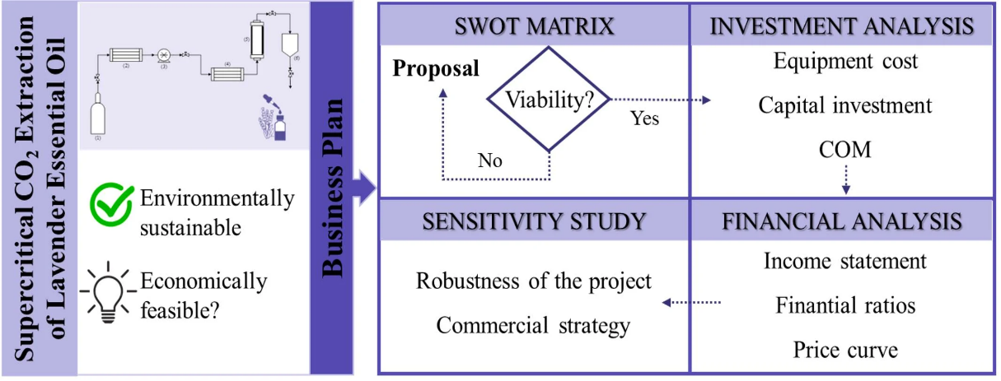

Graphical Abstract Title Maximum Six Words,
Excluding Prepositions and Conjunctions

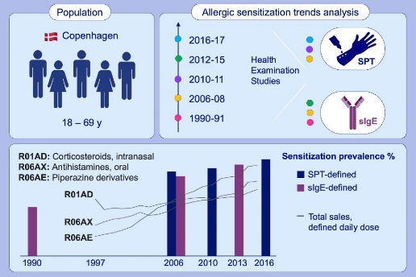

Graphical Abstract Title Maximum Six Words,
Excluding Prepositions and Conjunctions

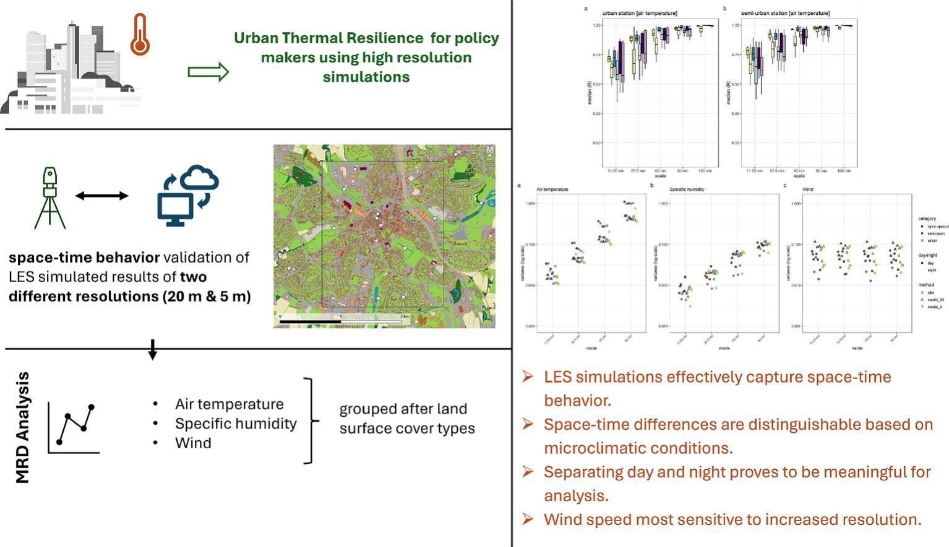

Graphical Abstract Title Maximum Six Words,
Excluding Prepositions and Conjunctions

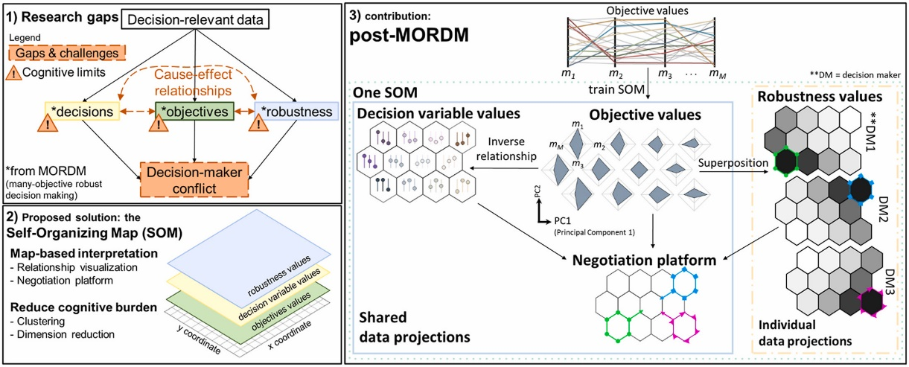

Graphical Abstract Title Maximum Six Words,
Excluding Prepositions and Conjunctions

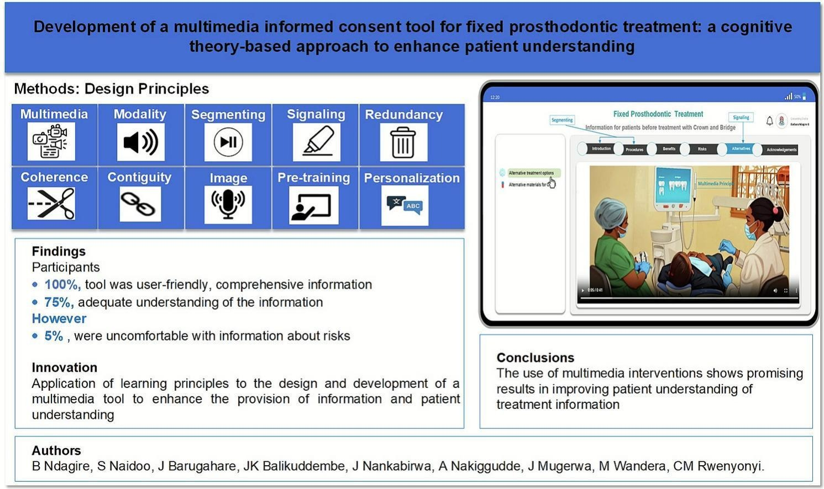

Graphical Abstract Title Maximum Six Words,
Excluding Prepositions and Conjunctions

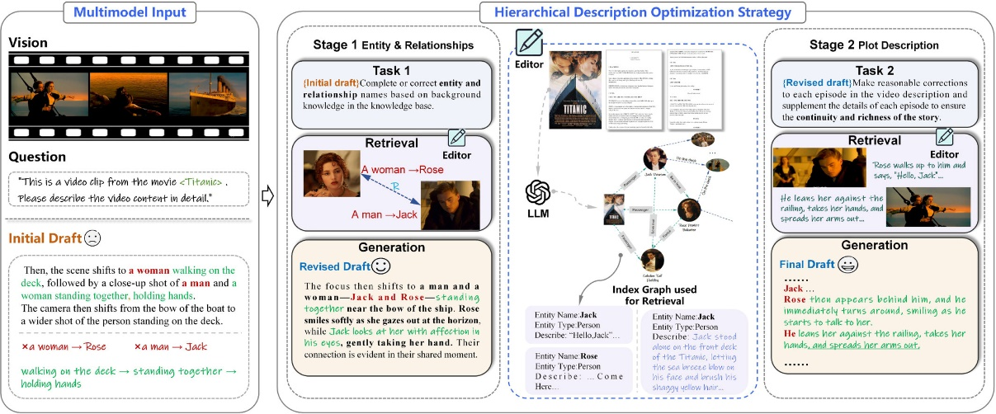

Graphical Abstract Title Maximum Six Words,
Excluding Prepositions and Conjunctions

